Understanding Autistic Burnout

Viv Dawes Autistic Advocate
www.autisticadvocate.co.uk

“Autistic burnout is a severely debilitating condition with onset preceded by fatigue from masking autistic traits, interpersonal interactions, an overload of cognitive input, a sensory environment unaccommodating to autistic sensitivities and/or other additional stressors or changes. Onset and episodes of autistic burnout may interact with co-occurring physical and or mental health conditions” (‘Investigating autistic burnout. Final report’, Dr S. Arnold, Julianne Higgins et al Feb 22)

“A state of physical and mental fatigue, heightened stress and diminished capacity to manage life skills, sensory input and social interactions, which comes from years of being severely overtaxed by the strain of trying to live up to demands that are out of sync with your needs” Judy Endow (www.judyendow.com/advocacy/autistic-burnout/)

Research by Dr S. Arnold and Julianne Higgins et al, found that the most common characteristics experienced were:

- Chronic exhaustion 72%
- Sensory overload 80%
- Heightened anxiety 90%
- Low mood 95%
- Increased shutdowns 80%
- Loss of skills 90%
- Suicidal thoughts 64%
- Intrusive thoughts 59%

The main causes of autistic burnout are
- Prolonged masking - often fawning, camouflaging, identity management in social situations and environments and a mostly subconscious protective trauma response to feeling unsafe in social environments (masking is not usually a choice an autistic person makes).
- Prolonged periods of time spent in social situations & environments that drain an autistic person of energy - because the environments are not in sync with the different needs of the autistic individual.
- Prolonged sensory overload - autistic people can be hyper and hypo sensitive to all their different senses.
- Too many expectations and demands -this is particularly an issue for those with a PDA profile who need more autonomy.
- Stigma – there is a great deal of stigma (surrounding autism and being autistic) that is essentially why most autistic people mask; they are not safe to be their authentic selves, due to a lack of inclusion, understanding, accommodations and environments not being safe spaces.

The Royal College of Psychiatrists describes autistic burnout as "a state of exhaustion, associated with functional and cognitive deterioration and an increase in autism symptomatology, as a consequence of coping with social interaction (including masking) and the sensory environment. It may be a short-lived state (as at the end of a working day), relieved by a relatively brief withdrawal from the stress. However, longer and more severe stress can produce a more sustained state (which entails some form of innate change) which has to wait on its natural remission. It overlaps symptomatically with anxiety and depression, and there may be a heightened risk of suicide.
Its anecdotal basis and the lack of systematic research mean that burnout does not have the status of a formal syndrome or disorder. Nevertheless, the concept captures the need to consider the effect of adjusting somebody’s setting, support, and style of life before assuming their malaise to be a recognised psychiatric disorder." (Royal College of Psychiatrists, The psychiatric management of autism in adults).

There are many crossovers between depression and autistic burnout, but it is important to understand the distinct differences. Treatment for depression does not work for an autistic person experiencing burnout and may actually exacerbate the burnout symptoms they experience and exhaust them further.
"While Autistic Burnout may co-occur with depression, it is distinct from it. Historically, Autistic Burnout may have been understood as depression. You may even have been diagnosed with depression by your GP when your symptoms might be more accurately understood as Autistic Burnout" Dr Alice Nicholls, ND Psychologist.
“In some cases, marginalised autistic people get stuck with mental health diagnoses that are even more reviled and misunderstood than Autism is. It’s quite common for autistic women to be incorrectly labelled with Borderline Personality Disorder (EUPD) ..... This is a really disastrous diagnosis and is many therapists’ least favourite condition to work with.” Dr Devon Price, (2022) ‘Unmasking Autism - The Power of Embracing Our Hidden Neurodiversity’.

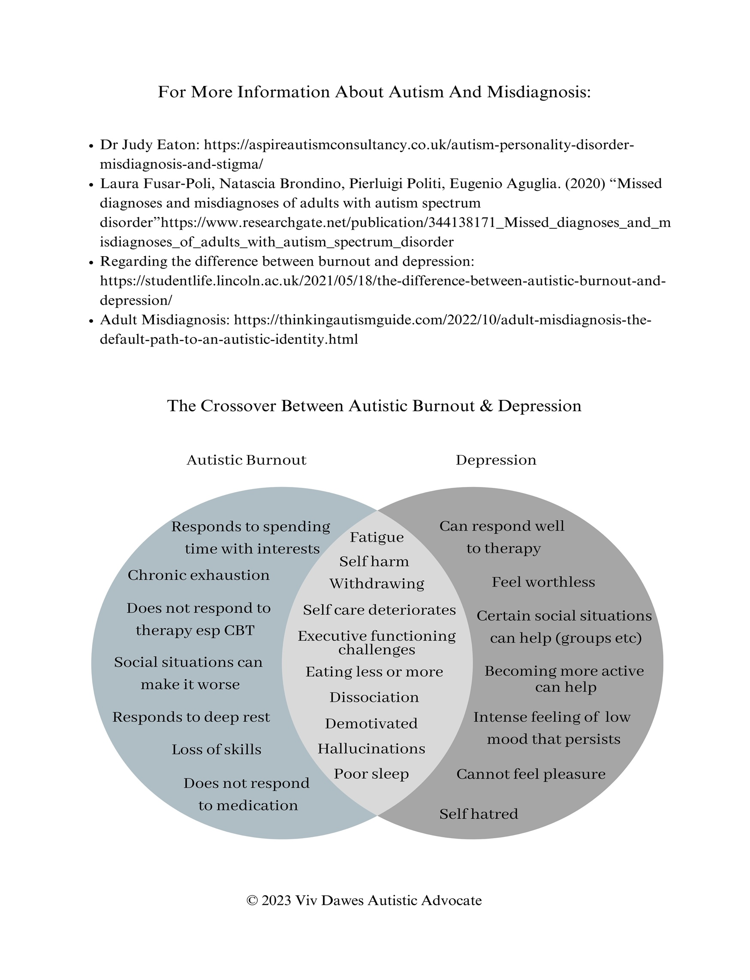

Research Papers

“Having All of Your Internal Resources Exhausted Beyond Measure and Being Left with No Clean-Up Crew”: Defining Autistic Burnout
https://www.ncbi.nlm.nih.gov/pmc/articles/PMC7313636/

“Understanding autistic burnout from experts with lived experience”

https://figshare.com/articles/online_resource/Understanding_autistic_burnout_from_experts_with_lived_experience/24659622

https://www.bps.org.uk/research-digest/study-explores-what-its-experience-autistic-burnout

“A conceptual model of risk and protective factors for autistic burnout”

https://www.researchgate.net/publication/359924348_A_conceptual_model_of_risk_and_protective_factors_for_autistic_burnout

“Defining autistic burnout”
https://www.autismcrc.com.au/sites/default/files/posters/3-076RI_Higgins_Defining_Autistic_Burnout_using_Grounded_Delphi_Method.pdf

“Confirming the nature of autistic burnout”
https://journals.sagepub.com/doi/abs/10.1177/13623613221147410

“Investigating autistic burnout. Final report”
https://www.autismcrc.com.au/sites/default/files/reports/3-076RI_Autistic-Burnout_Executive-summary.pdf

“Measuring and validating autistic burnout”
https://www.researchgate.net/publication/380097974_Measuring_and_validating_autistic_burnout

Other information

Royal college of psychiatry (Autistic burnout mentioned in report regarding psychiatric management of autism in adults)
https://www.rcpsych.ac.uk/improving-care/campaigning-for-better-mental-health-policy/college-reports/2020-college-reports/cr228

My evidence for parliamentary committee
https://committees.parliament.uk/writtenevidence/117253/pdf/

Downloads available on my website
https://www.autisticadvocate.co.uk/shop
https://www.autisticadvocate.co.uk/_files/ugd/14d85f_a9f0901ac51c48898add5114a7e6d9c8.pdf

Autistic burnout network
https://www.autisticadvocate.co.uk/autistic-burnout-network

Other lived experience experts on autistic burnout
Judy Endow - http://www.judyendow.com/
Keiran Rose - https://theautisticadvocate.com/
Helen Edgar (Autistic Realms) - https://www.autisticrealms.com/
Kristy Forbes - https://www.kristyforbes.com.au/

What helps an individual experiencing autistic burnout?

There are key things that make up recovery from burnout for an autistic person and this includes:

- Rest: There are 7 types of rest: Physical, Mental, Emotional, Social, Spiritual, Sensory and Creative.
Resting is crucial for recovery from autistic burnout and it can take time, for some a very long time (even years).

- Time with interests: Because autistic brains and nervous systems are ‘interest based’ (see Monotropism) therefore having plenty of time in flow states with their interests and passions (special interests) is really important and a way to not only rest but regulate and heal.

- Low/lower demands and expectations: High demands and expectations are often triggers for autistic burnout and so it is important that ordinary everyday demands, education and employment demands, social and communication demands etc are significantly reduced wherever possible.

- Time: You cannot rush recovery from autistic burnout. It is a process and you cannot set timescales either - as it is different for each autistic individual. This can be very challenging for autistic adults who are parent/carers (who may also be caring for children experiencing burnout). If they are working then time off work to rest is difficult, and it can mean many might lose jobs or have to leave. For autistic children and young people it often means attending school, college or university is usually impossible and more often alternative education pathways are required.

- Understanding capacity: Autistic people have differences in their social energy (made up of physical, mental and emotional energy). Their social energy can be affected by numerous things including: masking, sensory overload and too many demands upon them. – these are all exhausting. When burnt out, doing more and being in more social situations will exacerbate their experiences. Often, they naturally will seek out more alone time, as their nervous system seeks to heal.

- Neurokin and co regulation – autistic people will often feel safer with their neurokin (usually other autistic people they feel a connection with). It is easier to be unmasked when there are no neurotypical social expectations. Co regulation is also an important aspect of healing for an autistic person – regulation, connection, synergy and synchronicity with another.

- Autonomy – this is something autistic people need more of but especially if they have a PDA profile and it is really important in the recovery journey. Autonomy and having a sense of agency is crucial for feeling safe when PDA, or the trauma response is easily triggered.

