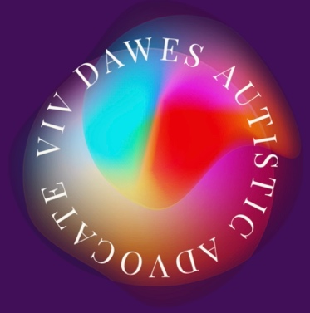

Understanding autism and the neurodiversity paradigm
From £175 for 2 hours

Viv Dawes is an autistic lived experience advocate, trainer and author and the parent of a neurodivergent young adult. She has over 25 years’ experience of working with vulnerable people, who were mostly neurodivergent, including as a Snr Practitioner in the NHS, managing teams of forensic drug workers in Surrey prisons. Viv has written various books about autistic burnout that have been endorsed by Tony Attwood amongst others.

Viv has provided training for numerous organisations including The YMCA, The National Autistic Society, Brain in hand and numerous others. She has been a keynote speaker at various Surrey county council events and spoke on autistic burnout at the London Autism Show in June 2024. Viv was also nominated for the National Diversity Awards for her work around helping people understand autistic burnout.

- What does it really mean to be autistic?
- What is the neurodiversity paradigm?
- The spectrum and spiky profiles
- Monotropism and the autistic brain and nervous system
- The double empathy problem
- Sensory needs - hypo and hyper sensitivities
- Social communication differences
- Masking - fawning, camouflaging and suppressing authenticity
- Meltdowns and shutdowns and being misinterpreted
- Burnout and capacity
- Burnout recovery

www.autisticadvocate.co.uk
dawesautismadvocate121@gmail.com

